**Gulmohar Maitri Website Evaluation for Further Rectification**

**Home Page**

* Home Page front page need some recent Image along with a clickable change
* Font size need to be changed & Big
* Home Page video should be the profile video of GM( Although It is Half Made-we can upload it to brief our ambition , objective and motto to our visitors)
* Size of Maithri care is improper, it may be under “Our Initiative” Title and it must have “Maitri Club International” and “Pink Parade”
* The Social Media Section is not getting updated Posts and looks dull too… It should be more attractive .
* Testimonial is still the Old version, Please make it as per given content.

**Testimony : {Updated}**

1. **Savita**

"I'm immensely grateful for Gulmohar Maitri's support during my breast cancer journey. Their awareness campaigns and resources helped me detect it early, and their emotional support made me feel empowered and never alone. Thanks to Gulmohar Maitri, I'm now a survivor and advocate for breast cancer awareness."

1. **Uraan**

"Gulmohar Maitri's dedication to raising awareness about cervical cancer, HPV vaccination, and menstrual hygiene is commendable. We've collaborated on projects reaching marginalized groups, empowering women to take charge of their health. Gulmohar Maitri's professionalism and passion make them an invaluable partner."

1. **Ruban Memorial Hospital**

"Gulmohar Maitri has had a positive impact on our community through their breast cancer awareness initiatives. Collaborating seamlessly, we've conducted screening camps, educating women on the importance of check-ups. Their efforts in cervical cancer prevention and menstrual health are also noteworthy."

1. **Priyanka Kumari**

"Thanks to Gulmohar Maitri, I received the HPV vaccination, and it has provided me with peace of mind and protection against cervical cancer. Their dedication to raising awareness and providing this vaccine is truly commendable. I encourage all girls and women to take advantage of this initiative for a healthier future. Thank you, Gulmohar Maitri!"

1. **Khilkhilahat Rainbow Homes**

"Gulmohar Maitri's commitment to menstrual hygiene and health is remarkable. Their programs have empowered women, providing crucial knowledge and resources. They've reached remote communities where awareness is lacking. Working with Gulmohar Maitri has been impactful in improving women's lives."

* Bottom Section’s Font/Size and Baldness is not proper & Professional

**About Us Section {Updated}**

* Executive team member image & introduction
* Case of Executive Member tab …It should be in Lowercase “ Executive Team”

**Introduction of team mates**

**Manju Sinha :** The Pandora box of expertise and experience. A leader and a courageous Social entrepreneur that takes risks from the front and counters every challenge ruthlessly. Manju Sinha, a dedicated social worker who wants to change the traditional establishment about breast cancer, cervical cancer and related taboo is leading as secretary of Gulmohar Maitri

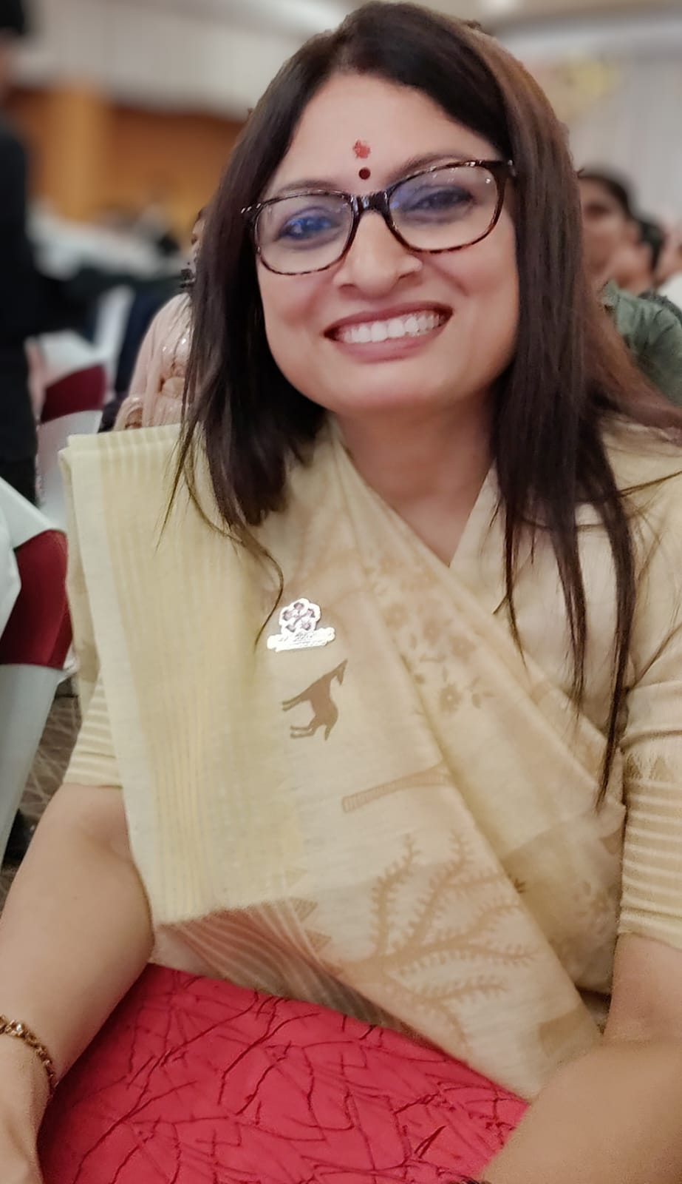

**Treasure- Rahul Ranjan**

**Director (Delhi Chapter)- Rashmi Mishra**

**Director (Bihar Chapter)- Amritesh Kumar**

**Prateek- Digital Campaign Head (National Team)**

**Rajiv Prashant- Legal Advisor (Bihar Chapter)**

**S.S Pandey- Legal Advisor (National Head)**

**Note:- Will be Updated Later**

**Neeraj Srivastava :** Dynamic Analyst with more than 26 years of multi-functional experience, responsible for creating new models that support business decisions by working closely with all teams to establish initiatives to improve & optimise costs. He is our Money Man as the head of CSR.

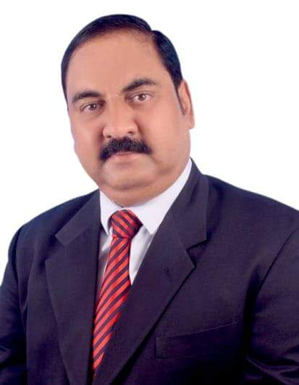

**Sanjeev Shekhar :** Competent and Hardworking Program Coordinator is more than his designation due to his high competency in overall management of our Program, camps and campaign. He is a MBA Degree holder mass mobiliser with great grip on common people’s sentiment and need.

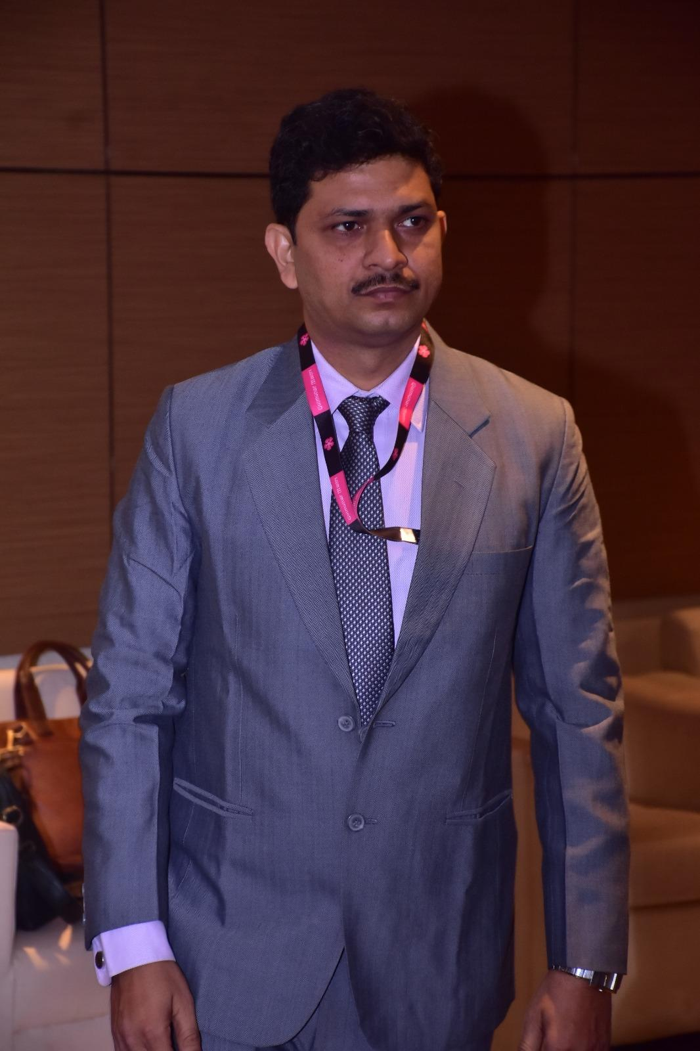

**Neha Singh :** Neha is a MBA (Marketing & Banking: Dual Specialisation) from Bangalore University with diverse work experience in n Digital Ad Sales, Affiliate marketing, Social media marketing, and Client handling with impeccable presentation, convincing capability and bewitching communication skill is the flag bearer of the company as head of operation.

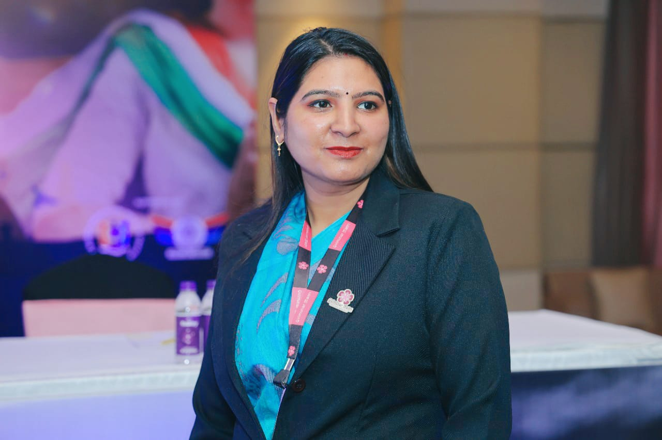

**Azhar Siddiqui:** Azhar is the Craftsman who is responsible for the conception, design, and on-brand execution of all visual print and digital marketing for Gulmohar Maitri.



**Vandana Singh :** Vandana is MBA(HR) is the most energetic member in our team who is always eager to Showcase our work and contribution.She is responsible for all kinds of social & Publicity Buzz of Gulmohar Maitri as our PR head.



**Ravi Kumar :** Man of diversity. Ravi can write, think, speak, and train, eventually a cocktail of knowledge and skill. He is the best as a content writer, unmatchable as a researcher and lovable as a Social media manager.

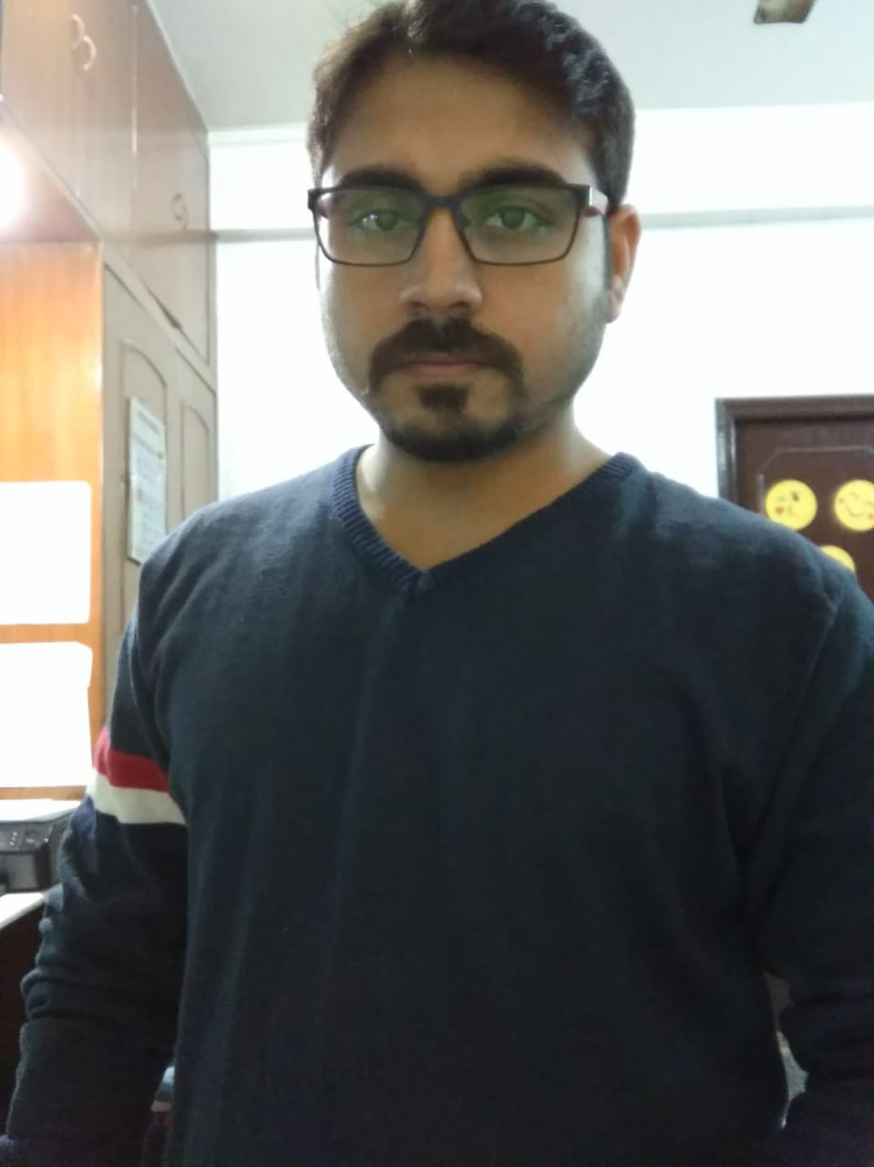

**What We Do Section**

* Need To Remove Maitri Care Title from this page heading {Add Works areas as a title}
* Ambition Page should have Graphical Representation {Required photo or Graphical Representation pattern}

**Maitri Care**

* Why is The title logo in Box? {Removed box}

**Our Initiative Page {Updated}**

* All Initiative Description should be synchronised with the font of rest of text in the website.
* Don’t Bold the Font, just increase the size of the text
* Image should be diverted onto the relevant section in gallery

**Media Section{Removed}**

Remove Field Work

**Event**

1. **13 years of Gulmohar Maitri{Replace 11 by 13 & Updated content}**

On 19th of March, we all gathered to celebrate our 13-year journey at BAMETI Campus, Patna. The event hosted stakeholders, advisory board, and esteemed guests like President Dr. Sahajanad Prasad Singh and Secretary Manju Sinha. The celebration recognized Gulmohar Maitri's impactful work in breast cancer, cervical cancer, and menstrual health. Inspiring speeches, a documentary on achievements, cultural performances, and testimonials showcased the organization's dedication. Gratitude was expressed to supporters for their contribution. The event reaffirmed the commitment to empower women and address crucial health issues. Gulmohar Maitri's 13-year milestone was a proud moment, inspiring continued support for their noble cause.

The event concluded with a heartfelt vote of thanks, expressing gratitude to all the individuals, partners, and stakeholders who supported Gulmohar Maitri throughout its journey.

The celebration served as a reminder of the ongoing battle against breast cancer, cervical cancer, and menstrual health issues. It reinforced the organization's determination to create a healthier and happier future for women.

Gulmohar Maitri's 13-year journey marked a milestone of success, inspiring attendees to further support the organization's noble cause. It highlighted the positive impact that can be made when individuals and communities come together for a common purpose.

1. **Navya Vaccination Drive{ updated}**

Navya- The beginning of womanhood is the most ambitious project of Gulmohar Maitri that executes through a series of vaccination drives throughout the year. It started on 2nd of october 2021 from Gyan Bhawan, where UNICEF Bihar’s chief Dr. S.Reddy, Our Brand Ambassador Hon’ble MLA Mrs. Shreyasi Sing, flag off this mega Project.

Navya Vaccination Drive,, aimed to protect adolescent girls between the ages of 11 to 17 from cervical cancer through HPV vaccination. In the last one year This vaccination drive took place in Shiwan twice(As HPV vaccine needed to be shot twice) and covered other various locations in Patna, including Khilkhilahat Rainbow Homes, Rajeev Nagar, Patna, slums near Haj Bhawan, Patna, and Ruban Memorial Hospital .

Over the course of the drive, nearly 100 girls were vaccinated twice on 1st july 2022 and 27th jan 2023 at Shiwa,On Dated 18th March 2021 at slums nearby Haj Bhawan, 17th june 2022 and 30th Jan 2023 at Ruban Hospital. In this way, we have vaccinated 111Girls twice till date and Planning to give this drive a rapid growth. Gulmohar Maitri's initiative focused on providing crucial protection against cervical cancer, a major health concern among women. By administering the HPV vaccine, the organisation aimed to empower these young girls and safeguard their future health.

The drive's presence in diverse locations ensured accessibility and inclusivity, reaching out to girls from different backgrounds and communities. Ruban Memorial Hospital's partnership contributed to the drive's success by providing medical expertise and support throughout the vaccination events.

Through the Navya Vaccination Drive, Gulmohar Maitri demonstrated its commitment to promoting women's health and preventing cervical cancer by equipping adolescent girls with the necessary protection. The drive's comprehensive approach and collaborative efforts with medical partners further solidified the organisation's dedication to this important cause.

1. **Cancer Awareness Drive{New page created & updated}**

Gulmohar Maitri conducted a Cancer Awareness Drive at various locations, including Khilkhilahat Rainbow Homes, Antardristi Blind School, as well as private and government schools, colleges, and coaching classes. The drive aimed to raise awareness about cancer and its prevention, emphasizing the importance of early detection and regular screenings.

At Khilkhilahat Rainbow Homes and Antardristi Blind School, special sessions were organized to educate children and teachers about the common types of cancer, their risk factors, and the significance of adopting a healthy lifestyle. The focus was on empowering individuals to make informed choices and take proactive steps towards cancer prevention.

In schools, colleges, and coaching classes, informative workshops and interactive sessions were conducted to educate students and young adults about cancer prevention, risk factors, and the importance of self-examinations. The drive aimed to dispel myths and provide accurate information to encourage early detection and timely medical intervention.

Gulmohar Maitri's Cancer Awareness Drive played a crucial role in reaching out to diverse audiences and promoting a culture of cancer awareness and prevention. By engaging with different educational institutions and organizations, the drive ensured that the message of early detection and prevention was disseminated widely.

Through these initiatives, Gulmohar Maitri aimed to empower individuals with knowledge, inspire them to adopt healthier lifestyles, and encourage regular screenings for early cancer detection. The organisation's efforts in conducting the Cancer Awareness Drive contributed to building a healthier and more informed community, fostering a proactive approach towards cancer prevention and overall well-being.

1. **Teeka Utsav Bhagidaari {updated}**

Gulmohar Maitri Social welfare Drive during COVID- 19 era with the association of NCC Udaan. We covered seven districts of Bihar and reached out 10-20 thousand people during our 47 days “Teeka Utsav Bhagidari” and helped people to get registration for Covid Vaccination and helped them to get vaccinated.

In This course, we help people with 30,810 litres of oxygen,24,246 food packets,33,550 packets of Kaddha,320 cartoons of Biscuits, and other help like transportation and awareness.